SCS31901 PROJECT PLAN

Squashies Jukebox

Music Control App



# Executive Summary

Squashlands Gym and Fitness is a well-known Gym and Fitness Centre in Liverpool, which require a jukebox-like application that allows for gym patrons to queue for songs to listen to while they are working out. With the gym patrons able to queue song, this leaves the administration/staff to be able to control and manage the song queues and playlist. To understand more about what additional features needed to be added into the application, an initial meeting needed to be set.

After emailing the main client, Angel, organising a first meeting, we sat down and discussed the project in depth, and uncovered more features that were required. Security and password control was one of the agendas, which allow only admin staff control of the song playlist and queues so anyone can’t just change it. Between the client and the team, we agreed that we would be using Windows 10 as our PC server and a web interface for the staff would be the more preferable option. There would be restrictions on the application. For example, gym patrons should only have a limited number of selections of songs at a time. The idea is that a gym patron will use one of the tablets around the gym, write down their name and choose a song from the playlist to add to the queue. Once the song is next to play, the music video will be playing onto the TV monitors which are also going to be around the gym.

After getting more of a detailed description about the project, we set up an initial meeting with Rhys, the academic supervisor, on how we should approach the project and what possible solutions should we be thinking of based on the client’s requirements. A possible solution suggested by Rhys was to create a client server based application where you create a Python server using Flask which constantly is sending requests to fetch more songs and adding them to a local database. With that, we would need to set this up on an HTML webpage for the staff to be able to access the songs that have been requested.

After acquiring more details from the main client and further assistance from the academic supervisor, the team went back to collaborate ideas and continue further research into how we are going to create this application. We worked out individual tasks based on each group member’s strengths and weaknesses and through regular meetings, we were able to begin planning and start working on those initial ideas and research.

# Table of Contents

**Executive Summary** **2**

**Table of Contents** **3**

**Introduction** **5**

**Group Details** **5**

Team Member: Joshua Incollingo 5

Team Member: Themis Giaras 6

Team Member: Dharmjit Kalay 6

**Work Breakdown Structure** **6**

**Project Management Related Issues and Risks** **6**

**Milestone Plan** **7**

**Individual Task List** **8**

Team Member: Joshua Incollingo 8

Team Member: Themis Giaras 8

Team Member: Dharmijit Kailay 9

**Planned Meetings** **9**

**Client Meetings** **10**

First Meeting 10

Second Meeting 11

**Academic Supervisor/Mentor Meetings** **11**

First Meeting 11

Second Meeting 12

**Team Meetings** **13**

First Meeting 13

Second Meeting 14

Third Meeting 14

Fourth Meeting 15

Fifth Meeting 16

**Communication Taken Place Thus Far** **17**

Agenda and Minutes 17

Client 17

First Meeting 17

Second Meeting 19

Academic Supervisor 21

First Meeting 21

Second Meeting 23

Team 25

First Meeting 25

Third Meeting 29

Fourth Meeting 30

Fifth Meeting 31

Emails 33

Scheduling our First Meeting with Client 33

Scheduling Regular Meetings with Client 34

Organising Regular Weekly Meetings With Academic Supervisor 34

Sending Agendas for Second Academic Supervisor Meeting 35

**Gantt Chart** **35**

**Conclusion** **35**

# 

# 

# 

# 

# 

# 

# Introduction

With every good gym and fitness centre comes a high-quality music system. Often when people are going to the gym to do a workout, having good music playing

throughout can often motivate them to achieve their fitness goals. Squashlands Gym and Fitness Centre is an established gym in the heart of Liverpool that understands just how important music is to their gym and for working out. This is why the idea of a Jukebox application has come into play.

The aim for this Jukebox application is to allow gym patrons to queue for songs on the Squashland’s playlist. For the administration staff, they will be able to manage the song playlist and control the song queues from the patrons. Through an initial client meeting, we, as the team members, will be able to understand more about the Jukebox application and what the client’s expectations and requirements are from it, as well as any other additional features that were not covered in the project brief.

In this project plan, we will define the following:

* Group Details (Strengths and Weaknesses in 4 Key Areas)
* Work Breakdown Structure
* Planned Meetings (With Client, Academic Supervisor and Team)
* Agendas and Minutes (With Client, Academic Supervisor and Team)
* Project Management Issues and Risks
* Initial Milestone Plan
* Communication Thus Far (With Client and Academic Supervisor)
* Gantt Chart

# Group Details

## Team Member: Joshua Incollingo

| **Programming** | **User Interface** | **Documentation** | **Research** |
| --- | --- | --- | --- |
| Above average | Strong | Above average | Average |

## 

## Team Member: Themis Giaras

| **Programming** | **User Interface** | **Documentation** | **Research** |
| --- | --- | --- | --- |
| Strong | Strong | Weak | Strong |

## Team Member: Dharmjit Kalay

| **Programming** | **User Interface** | **Documentation** | **Research** |
| --- | --- | --- | --- |
| Average | Average | Strong | Average |

# Work Breakdown Structure

Please refer to the separate PDF file “Work Breakdown Structure FULL”.

# Project Management Related Issues and Risks

| **Risk/Issue** | **Resolution Expected to be Actioned** |
| --- | --- |
| Project Requirements are not Fully Clarified/Limited | Team will have to attend a good number of client meetings to set things clear |
| Falling Behind with Task Completions | Team will have to gather preferably more resources and if required allocate extra time |
| Lack of Proper Communication | Ensure all team members are involved during decision making and discussions. Ensure client, supervisor and team are all on the same page to get the best outcome in terms of project output |
| Technically Not Doable Client Requests | Resolve such issues through prompt client and supervisor meetings/discussions |
| Unable to Have Regular Meetings with the Other Team Members | Communicate with members and choose a favourable time that suits the majority |
| Project Scope Changes | Assess the impact it may have on the project and notify client and supervisor. Request for extra time if required, to implement this change |
| Not Meeting Client Expectations | Ensure the product complies with client’s expectations, by discussing the team’s strengths, weaknesses and skill set and agreeing on the best design specification that will fulfil client requirements |
| Team Shortcomings | Team will have to be prepared to be cooperative, so that any shortcomings that may arise due to lack of skill, knowledge or unexpected inconvenience, can be handled well without affecting project deadline. |

# Milestone Plan

| **Milestone** | **Main Responsibility** | **Planned Date** | **Actual Date**  **(To be Reported in the Completion Report)** |
| --- | --- | --- | --- |
| Project Plan | Joshua | 22/11/2019 |  |
| Project Proposal | Everyone | 29/11/2019 |  |
| System Analysis Report | Everyone | 03/01/2020 |  |
| Working Prototype | Themis | 13/12/2019 |  |
| Final System Implementation | Themis | 31/01/2020 |  |
| Handover and Completion Report | Everyone | 31/01/2020 |  |
| Final Presentation | Everyone | 07/02/2020 |  |
| Project Abstract and Video | Everyone | 07/02/2020 |  |
| Academic Panel Presentation | Everyone | Week 14, starting 03/02/2020 |  |

# 

# Individual Task List

## Team Member: Joshua Incollingo

| **Task** | **Phase** | **Start Date** | **End Date** | **% Complete** |
| --- | --- | --- | --- | --- |
| Group Details | Project Plan | 13/11/2019 | 13/11/2019 | 100 |
| Milestone Plan | Project Plan | 13/11/2019 | 22/11/2019 | 100 |
| Individual Task List | Project Plan | 15/11/2019 | 20/11/2019 | 100 |
| Communication So Far | Project Plan | 13/11/2019 | 22/11/2019 | 100 |
| Formatting Project Plan | Project Plan | 13/11/2019 | 22/11/2019 | 100 |
| Submit to VUWS | Project Plan | 22/11/2019 | 22/11/2019 | 100 |

## Team Member: Themis Giaras

| **Task** | **Phase** | **Start Date** | **End Date** | **% Complete** |
| --- | --- | --- | --- | --- |
| Group Details | Project Plan | 13/11/2019 | 13/11/2019 | 100 |
| Individual Task List | Project Plan | 15/11/2019 | 20/11/2019 | 100 |
| Gantt Chart | Project Plan | 20/11/2019 | 21/11/2019 | 100 |
| Work Breakdown Structure | Project Plan | 20/11/2019 | 21/11/2019 | 100 |

## Team Member: Dharmijit Kailay

| **Task** | **Phase** | **Start Date** | **End Date** | **% Complete** |
| --- | --- | --- | --- | --- |
| Group Details | Project Plan | 13/11/2019 | 13/11/2019 | 100 |
| Management Issues and Risks | Project Plan | 19/11/2019 | 21/11/2019 | 100 |
| Individual Tasks List | Project Plan | 15/11/2019 | 20/11/2019 | 100 |

# Planned Meetings

| **Meeting Type** | **Length** | **First Meeting** | **How Often** | **No. of Meetings Planned** | **Location and Form of Meeting** |
| --- | --- | --- | --- | --- | --- |
| Client Meeting | 45 mins to 1 hour | 13/11/2019 at 9:15am | Weekly | 12 | Face to face meeting at client’s Ingleburn office |
| Academic Supervisor Meeting | 45 minutes to 1 hour | 13/11/2019 at 4:30pm | Weekly | 12 | Face to face meeting at Western Sydney University Level 4 (Sydney City Campus) |
| Group Meeting | 2 hours | 06/11/2019 at 2:00pm | 1-2 days a week | ~ 15-25 | Face to face meeting at Western Sydney University (Sydney City Campus)  AND  Online via Discord |

# Client Meetings

## First Meeting

* Project Number: SCS31901
* Meeting Type: Client
* Meeting Date: 13/11/2019
* Location: Face-to-Face Meeting at Client’s Site in Ingleburn
* Start Time: 9:15am
* Duration: 45 minutes to 1 hour
* Chairperson: Joshua Incollingo
* Invitees: Themis Giaras, Dharmijit Kailay

1. **Purpose of Meeting**

* Getting a more detailed description of the project and what it entails
* Bit of background information of Squashlands Gym Fitness Centre and how it’s been running currently in terms of their music system
* Working out new features for the new Jukebox system

1. **Agenda Items**

| Item | Description | Who | Time |
| --- | --- | --- | --- |
| 1 | Detailed Description of the Project | Everyone | 15 mins |
| 2 | Music - How is being handled? | Everyone | 5 mins |
| 3 | Music - Is It Stored Locally? | Everyone | 15 mins |
| 4 | Number of Tablets Gym Patrons/Staff Will Use | Everyone | 5 mins |
| 5 | Separate App for Patrons/Admin? | Everyone | 5 mins |
| 6 | Additional Features for New System | Everyone | 20 mins |
| 7 | Organising Next Meeting | Everyone | 5 mins |

## Second Meeting

* Project Number: SCS31901
* Meeting Type: Client
* Meeting Date: 20/11/2019
* Location: Face-to-Face Meeting at Client’s Site in Ingleburn
* Start Time: 10am
* Duration: 30 minutes
* Chairperson: Joshua Incollingo
* Invitees: Themis Giaras, Dharmijit Kailay

1. **Purpose of Meeting**

* Discussing our possible solutions we are thinking of using (web interface for staff)
* Confirming the specifics for the system (Windows 10, Linux?)
* Confirming the OS of tablets (Android Jellybean, Google Android 4.2, etc.)

1. **Agenda Items**

| Item | Description | Who | Time |
| --- | --- | --- | --- |
| 1 | Possible Solutions | Everyone | 15 mins |
| 2 | Specifics for the System | Everyone | 15 mins |
| 3 | OS of Tablets | Everyone | 15 mins |
| 4 | Planning Next Actions to be Completed | Everyone | 15 mins |
| 5 | Confirm Next Meeting | Everyone | 5 mins |

# Academic Supervisor/Mentor Meetings

## First Meeting

* Project Number: SCS31901
* Meeting Type: Academic Supervisor
* Meeting Date: 13/11/2019
* Location: Face-to-Face Meeting at Western Sydney University, on Level 4
* Start Time: 4:00pm
* Duration: 45 minutes to 1 hour
* Chairperson: Joshua Incollingo
* Invitees: Themis Giaras, Dharmijit Kailay

1. **Purpose of Meeting**

* After first client meeting, it’s important to get advice from the supervisor in regards to any tips for this project and how we can achieve the best result possible
* Need a second opinion on some initial ideas on how to approach the project

1. **Agenda Items**

| Item | Description | Who | Time |
| --- | --- | --- | --- |
| 1 | Best Language to Use Based on Client’s Requirements | Everyone | 10 mins |
| 2 | Best Format for the System | Everyone | 10 mins |
| 3 | Possible Tips for the Project | Everyone | 10 mins |
| 4 | Possible to Use Pre-Existing Applications and then Modify Them Based on Client’s Requirements? | Everyone | 10 mins |
| 5 | Organising Next Meeting | Everyone | 5 mins |

## Second Meeting

* Project Number: SCS31901
* Meeting Type: Academic Supervisor
* Meeting Date: 20/11/2019
* Location: Face-to-face Meeting at Western Sydney University on Level 4
* Start Time: 4:30pm
* Duration: 45 minutes to 1 hour
* Chairperson: Joshua Incollingo
* Invitees: Themis Giaras, Dharmijit Kailay

1. **Purpose of Meeting**

* Assigning specific tasks per member based on our group details
* More clarification on Work Breakdown Structure
* More clarification on Gantt Chart format

1. **Agenda Items**

| Item | Description | Who | Time |
| --- | --- | --- | --- |
| 1 | Assigning our Individual Tasks | Everyone | 15 mins |
| 2 | Work Breakdown Structure | Everyone | 15 mins |
| 3 | Gantt Chart Format | Everyone | 15 mins |
| 4 | Confirm Next Meeting | Everyone | 5 mins |

# Team Meetings

## First Meeting

* Project Number: SCS31901
* Meeting Type: Team
* Meeting Date: 06/11/2019
* Location: Face-to-Face Meeting at Western Sydney University on Level 2
* Start Time: 2pm
* Duration: 30 minutes
* Chairperson: Joshua Incollingo
* Invitees: Themis Giaras, Dharmijit Kailay

1. **Purpose of Meeting**

* As it’s our first meeting, this is predominantly used for each member to introduce themselves and identify any strengths and weaknesses in regards to working in a group
* It’s also the first time we, as a group, will read the project description, and get an understanding on what exactly needs to be made
* Begin to start planning meetings with the client

1. **Agenda Items**

| Item | Description | Who | Time |
| --- | --- | --- | --- |
| 1 | Introducing Ourselves to all Group Members | Everyone | 10 minutes |
| 2 | Going Over the Project Description | Everyone | 5 minutes |
| 3 | Discussing our Strengths and Weaknesses | Everyone | 10 minutes |
| 4 | Begin Organising First Client Meeting | Everyone | 5 minutes |

## Second Meeting

* Project Number: SCS31901
* Meeting Type: Team
* Meeting Date: 13/11/2019
* Location: Face-to-Face Meeting at Western Sydney University on Level 2
* Start Time: 11am
* Duration: 40 minutes
* Chairperson: Joshua Incollingo
* Invitees: Themis Giaras, Dharmijit Kailay

1. **Purpose of Meeting**

* After our first meeting with the client, it’s important as a group, we discuss what we said in that meeting and to start coming up with ideas on how we will make the new system

1. **Agenda Items**

| Item | Description | Who | Time |
| --- | --- | --- | --- |
| 1 | Reflection of First Client Meeting | Everyone | 10 minutes |
| 2 | Research | Everyone | 20 minutes |
| 3 | Organising Next Team Meeting via Discord | Everyone | 10 minutes |

## Third Meeting

* Project Number: SCS31901
* Meeting Type: Team
* Meeting Date: 14/11/2019
* Location: Online via Discord
* Start Time: 10pm
* Duration: 45 minutes
* Chairperson: Joshua Incollingo
* Invitees: Themis Giaras, Dharmijit Kailay

1. **Purpose of Meeting**

* Organise agendas for client and supervisor
* Plan our strategy for how we will complete the project plan

1. **Agenda Items**

| Item | Description | Who | Time |
| --- | --- | --- | --- |
| 1 | Understanding our Group Details | Everyone | 10 minutes |
| 2 | Assigning our Individual Tasks | Everyone | 10 minutes |
| 3 | Organising our Agendas for Next Meetings with Client and Supervisor | Everyone | 10 minutes |

#### 

## Fourth Meeting

* Project Number: SCS31901
* Meeting Type: Team
* Meeting Date: 20/11/2019
* Location: Face-to-Face Meeting at Western Sydney University on Level 4
* Start Time: 11:30am
* Duration: 45 minutes
* Chairperson: Joshua Incollingo
* Invitees: Themis Giaras, Dharmijit Kailay

1. **Purpose of Meeting**

* Looking into making a server using Python
* Researching Scrolling Messages in VLC
* Planning our Next Actions to Finish Project Plan

1. **Agenda Items**

| Item | Description | Who | Time |
| --- | --- | --- | --- |
| 1 | Creating a Server through Python | Everyone | 15 minutes |
| 2 | Researching Scroll Messages in VLC | Everyone | 15 minutes |
| 3 | Finalising Project Plan | Everyone | 15 minutes |

## Fifth Meeting

* Project Number: SCS31901
* Meeting Type: Team
* Meeting Date: 20/11/2019
* Location: Online via Discord
* Start Time: 10pm
* Duration: 45 minutes
* Chairperson: Joshua Incollingo
* Invitees: Themis Giaras, Dharmijit Kailay

1. **Purpose of Meeting**

* Getting a progress update with all group members to see how they’re going with their individual tasks to which they are assigned
* Finalising the Project Plan and wrapping it up before the due date (22/11/2019 at midnight)
* Planning our next actions to be completed after our project plan

1. **Agenda Items**

| Item | Description | Who | Time |
| --- | --- | --- | --- |
| 1 | Progress Update for Each Group Member | Everyone | 15 minutes |
| 2 | Finalising Project Plan | Everyone | 15 minutes |
| 3 | Planning Next Action for After Project Plan | Everyone | 15 minutes |

#### 

# Communication Taken Place Thus Far

## Agenda and Minutes

### Client

#### First Meeting

* Project Number: SCS31901
* Meeting Type: Client
* Meeting Date: 13/11/2019
* Location: Face-to-Face Meeting at Client’s Site in Ingleburn
* Start Time: 9:15am
* Duration: 45 minutes to 1 hour
* Chairperson: Joshua Incollingo
* Invitees: Themis Giaras, Dharmijit Kailay

1. **Purpose of Meeting**

* Getting a more detailed description of the project and what it entails
* Bit of background information of Squashlands Gym Fitness Centre and how it’s been running currently in terms of their music system
* Working out new features for the new Jukebox system

1. **Agenda Items**

| Item | Description | Who | Time |
| --- | --- | --- | --- |
| 1 | Detailed Description of the Project | Everyone | 15 mins |
| 2 | Music - How is being handled? | Everyone | 5 mins |
| 3 | Music - Is It Stored Locally? | Everyone | 15 mins |
| 4 | Number of Tablets Gym Patrons/Staff Will Use | Everyone | 5 mins |
| 5 | Separate App for Patrons/Admin? | Everyone | 5 mins |
| 6 | Additional Features for New System | Everyone | 20 mins |
| 7 | Organising Next Meeting | Everyone | 5 mins |

* Project Number: SCS31901
* Meeting Type: Client
* Meeting Date: 13/11/2019
* Location: Face-to-Face Meeting at Client’s Site in Ingleburn
* Start Time: 9:15am
* Duration: 45 minutes to 1 hour
* Chairperson: Joshua Incollingo
* Present: Joshua Incollingo, Themis Giaras, Angel Georgieff
* Absentees: Dharmijit Kailay
* Minutes Recorded By: Joshua Incollingo

1. **Discussions and Outcome**

Item 1: Detailed Description of Project

* Item 2: How is Music Being Handled?

Through music videos which have been downloaded

* Item 3: Is the Music Stored Locally?

The music is stored in a local video library

* Item 4: How Many Devices Will Patrons/Staff Use?

Ideally 3-4 tablets for admin (password control) and gym patron access

* Item 5: Separate App for Patrons and Admin?

Entirely up to the team

Item 6: Additional Features for System

* Admin side control functionality
* Around 5 selections per user → restriction can be altered by admin
* Record keeping of statistics of what songs were selected, and how many times they were selected, what time of the day they were selected, etc. (Timestamp)
* Gym patrons can add their name before they’re selecting music (Part of statistics)
* Android control would be more ideal, rather than iPhone
* Native app (more stable)
* Setting up static IP’s
* Restriction → only one song played once in an hour or so
* Main Features
  + Song Queue Management
  + Song Search
  + Advertisement Management
  + Staff Queue Management
  + Song Analytics

Item 7: Organise Next Meeting

* Planning to organise a meeting once a week, preferably Wednesday mornings
* This was agreed between client and team members, however time may vary week-to-week depending on client’s availability with his other commitments

1. **Actions to be Completed for Next Meeting**

* Research on what was discussed/features of the application
* Begin writing the project plan

#### Second Meeting

Project Number: SCS31901

* Meeting Type: Client
* Meeting Date: 20/11/2019
* Location: Face-to-Face Meeting at Client’s Site in Ingleburn
* Start Time: 10am
* Duration: 30 minutes
* Chairperson: Joshua Incollingo
* Invitees: Themis Giaras, Dharmijit Kailay

1. **Purpose of Meeting**

* Discussing our possible solutions we are thinking of using (web interface for staff)
* Confirming the specifics for the system (Windows 10, Linux?)
* Confirming the OS of tablets (Android Jellybean, Google Android 4.2, etc.)

1. **Agenda Items**

| Item | Description | Who | Time |
| --- | --- | --- | --- |
| 1 | Possible Solutions | Everyone | 15 mins |
| 2 | Specifics for the System | Everyone | 15 mins |
| 3 | OS of Tablets | Everyone | 15 mins |
| 4 | Planning Next Actions to be Completed | Everyone | 15 mins |
| 5 | Confirm Next Meeting | Everyone | 5 mins |

* Project Number: SCS31901
* Meeting Type: Client
* Meeting Date: 20/11/2019
* Location: Face-to-Face Meeting at Client’s Site in Ingleburn
* Start Time: 10am
* Duration: 30 minutes
* Chairperson: Joshua Incollingo
* Present: Joshua Incollingo, Themis Giaras, Angel Georgieff, George Georgieff
* Absentees: Dharmijit Kailay
* Minutes Recorded By: Joshua Incollingo

1. **Discussions and Outcome**

Item 1: Possible Solutions

* Mopidy, with the Python Script Web Extension

We discussed that Mopidy was a music management server where music can be played anywhere locally. However, it only allows audio, not music videos so trying to recreate the wheel for something that doesn’t completely satisfy the requirements for the new system could be an issue

* Web Interface/App Version for Staff

Web Interface more preferred

* Windows 10 PC as the Server

Item 2: Specifics of the System

* Windows 10 was agreed instead of Linux, between both the clients and the team, as it allows better file sharing and easier use and more predictability

Item 3: OS of Tablet

* Anything from Android Version 4.4 onwards is ideal

Item 4: Extra Comments/Questions

* Architecture of the System **(Asked by George, Angel’s Son)**

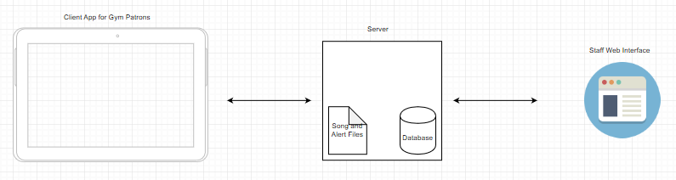

* Accessing Statistics Based on Song Genre? **(Asked by Themis)**

Not based on genre - based on song title and artist. Search based on timestamp/time queries (hour, day, week, month). The system needs to have an export feature so the client may export the data into another file format e.g. CSV Excel

* Possible to have a Scrolling Message Across the Screens? **(Asked by Angel)**

VLC might have a built-in function/module that may be able to accomplish this, should it should be doable. Ideally, the system should allow the message format to be altered. This feature is not vital, but if available, could be very handy.

1. **Actions to be Completed for Next Meeting**

* Draft project proposal
* Sign off sometime next week

### Academic Supervisor

#### First Meeting

* Project Number: SCS31901
* Meeting Type: Academic Supervisor
* Meeting Date: 13/11/2019
* Location: Face-to-Face Meeting at Western Sydney University, on Level 4
* Start Time: 4:00pm
* Duration: 45 minutes to 1 hour
* Chairperson: Joshua Incollingo
* Invitees: Themis Giaras, Dharmijit Kailay

1. **Purpose of Meeting**

* After first client meeting, it’s important to get advice from the supervisor in regards to any tips for this project and how we can achieve the best result possible
* Need a second opinion on some initial ideas on how to approach the project

1. **Agenda Items**

| Item | Description | Who | Time |
| --- | --- | --- | --- |
| 1 | Best Language to Use Based on Client’s Requirements | Everyone | 10 mins |
| 2 | Best Format for the System | Everyone | 10 mins |
| 3 | Possible Tips for the Project | Everyone | 10 mins |
| 4 | Possible to Use Pre-Existing Applications and then Modify Them Based on Client’s Requirements? | Everyone | 10 mins |
| 5 | Organising Next Meeting | Everyone | 5 mins |

* Project Number: SCS31901
* Meeting Type: Academic Supervisor
* Meeting Date: 13/11/2019
* Location: Face-to-Face Meeting at Western Sydney University, on Level 4
* Start Time: 4:00pm
* Duration: 45 minutes to 1 hour
* Chairperson: Joshua Incollingo
* Present: Joshua Incollingo, Themis Giaras, Rhys Tague
* Absentees: Dharmijit Kailay
* Minutes Recorded By: Joshua Incollingo

1. **Discussions and Outcomes**

Item 1: Best Language to Use Based on Client’s Requirements

* Python would be the preferable options, as python and flask (web framework for Python) can be used to connect to a HTML page (which is the webpage for client/staff)

Item 2: Best Format for the System

* Client/server based is the most ideal format for this project

Item 3: Possible Tips of the Project

* It’s important that we really work hard as a team, really cooperate with each other out where possible
* In any strong team, there’s strong communication
* If there are any internal issues within the group, please see the academic supervisor as soon as possible so it can be resolved sooner rather than later

Item 4: Possible to Use Pre-Existing Application and Modify Based on Client’s Requirements?

* It’s something that is worth exploring.
* If we can fully understand the way it works and can create a very high-quality client server interface, that could work
* But it’s important we do our research on this because you don’t want to waste our time on something that doesn’t suit what we’re trying to make

Item 5: Organising our Next Meeting

* Confirm regular weekly meetings with academic supervisor

1. **Actions to be Completed for Next Meeting**

* Research into Mopidy, Python and Flask
* Work out your Architecture for the System

#### Second Meeting

* Project Number: SCS31901
* Meeting Type: Academic Supervisor
* Meeting Date: 20/11/2019
* Location: Face-to-face Meeting at Western Sydney University on Level 4
* Start Time: 4:30pm
* Duration: 45 minutes to 1 hour
* Chairperson: Joshua Incollingo
* Invitees: Themis Giaras, Dharmijit Kailay

1. **Purpose of Meeting**

* Assigning specific tasks per member based on our group details
* More clarification on Work Breakdown Structure
* More clarification on Gantt Chart format

1. **Agenda Items**

| Item | Description | Who | Time |
| --- | --- | --- | --- |
| 1 | Assigning our Individual Tasks | Everyone | 15 mins |
| 2 | Work Breakdown Structure | Everyone | 15 mins |
| 3 | Gantt Chart Format | Everyone | 15 mins |
| 4 | Confirm Next Meeting | Everyone | 5 mins |

* Project Number: SCS31901
* Meeting Type: Academic Supervisor
* Meeting Date: 20/11/2019
* Location: Face-to-Face Meeting at Western Sydney University, on Level 4
* Start Time: 4:30pm
* Duration: 45 minutes
* Chairperson: Joshua Incollingo
* Present: Joshua Incollingo, Themis Giaras, Rhys Tague
* Absentees: Dharmijit Kailay
* Minutes Recorded By: Joshua Incollingo

1. **Discussions and Outcomes**

Item 1: Assigning Final Individual Tasks e.g. WBS

* Whoever has been assigned to do the Gantt Chart (Themis) should be the one doing the Work Breakdown Structure, since they can both be done on the same software.
* Recommended to use a software called ProjectLibre - fill out the WBS and then map it with time for the Gantt Chart

Item 2: WBS Format

* WBS is the whole project, on a tree-based diagram
* The branches are the major elements of the project e.g. Project Plan, Project Proposal, Working Prototype, etc.
* And inside those branches are what the project entails e.g. Project Plan includes Project Management Issues and Risks, Communication Thus Far, etc.

Item 3: Gantt Chart Format

* Map it out based on time

Item 4: Extra Comments

* VLC Discussion

Select query and group based on date, day, week, month, etc. Check out VLC HTTP Request on Wikipedia for more research. Pip install xmltodict in the Python server

* Log In System

Perhaps just a pin for the client to use as part of a security measure

* Working with SQL and Flask

Earlier Themis and I (Joshua) worked around with creating a server for the project, using Python. We should Rhys and received generally positive feedback on it thus far. Moving forward, we need to send requests through flask who talks to VLC, then wrap everything in the flask and call the request so it updates the playlist.

* Scrolling Messages

We can only initialise it on the startup, but we should be able to change its variables during runtime. More research needs to be done on this section.

1. **Actions to be Completed for Next Meeting**

* Finalise project plan
* More research e.g. VLC HTTP Requests, Scrolling Messages

### Team

#### First Meeting

* Project Number: SCS31901
* Meeting Type: Team
* Meeting Date: 06/11/2019
* Location: Face-to-Face Meeting at Western Sydney University on Level 2
* Start Time: 2pm
* Duration: 30 minutes
* Chairperson: Joshua Incollingo
* Invitees: Themis Giaras, Dharmijit Kailay

1. **Purpose of Meeting**

* As it’s our first meeting, this is predominantly used for each member to introduce themselves and identify any strengths and weaknesses in regards to working in a group
* It’s also the first time we, as a group, will read the project description, and get an understanding on what exactly needs to be made
* Begin to start planning meetings with the client

1. **Agenda Items**

| Item | Description | Who | Time |
| --- | --- | --- | --- |
| 1 | Introducing Ourselves to all Group Members | Everyone | 10 minutes |
| 2 | Going Over the Project Description | Everyone | 5 minutes |
| 3 | Discussing our Strengths and Weaknesses | Everyone | 10 minutes |
| 4 | Begin Organising First Client Meeting | Everyone | 5 minutes |

* Project Number: SCS31901
* Meeting Type: Team
* Meeting Date: 06/11/2019
* Location: Face-to-Face Meeting at Western Sydney University, on Level 4
* Start Time: 2pm
* Duration: 30 minutes
* Chairperson: Joshua Incollingo
* Present: Joshua Incollingo, Themis Giaras, Dharmijit Kailay
* Absentees: None
* Minutes Recorded By: Joshua Incollingo

1. **Discussions and Outcome**

Item 1: Introducing Ourselves to all Group Members

* Themis and I (Joshua) have known and worked with each other since the start of our degree so there was no real need to introduce ourselves again
* Dharimijit comes from an accounting degree background and travels to uni from Greater Western Sydney

Item 2: Going Over the Project Description

* Looking over the project description, it seems like a very straightforward application the client is asking for
* All three of us members were very excited and optimistic about what the project entails

Item 3: Discussing our Strengths and Weaknesses

* In every group, it’s important we go through each member’s strengths and weaknesses at the beginning of the project
* Dharmijit said he was not very strong in terms of programming but is good at documentation
* Themis said he was very strong at programming but not so confident in documentation
* I (Joshua) said that I was strong in regards to user interface and I was above average in documentation and programming but needed a bit of work in terms of research

1. **Actions to Be Completed for Next Meeting**

* Setting up a Discord server so we can do audio conferences outside the campus
* Organising our first meetings with the client and supervisor

Second Meeting

* Project Number: SCS31901
* Meeting Type: Team
* Meeting Date: 13/11/2019
* Location: Face-to-Face Meeting at Western Sydney University on Level 2
* Start Time: 11am
* Duration: 40 minutes
* Chairperson: Joshua Incollingo
* Invitees: Themis Giaras, Dharmijit Kailay

1. **Purpose of Meeting**

* After our first meeting with the client, it’s important as a group, we discuss what we said in that meeting and to start coming up with ideas on how we will make the new system

1. **Agenda Items**

| Item | Description | Who | Time |
| --- | --- | --- | --- |
| 1 | Reflection of First Client Meeting | Everyone | 10 minutes |
| 2 | Research | Everyone | 20 minutes |
| 3 | Organising Next Team Meeting via Discord | Everyone | 10 minutes |

* Project Number: SCS31901
* Meeting Type: Team
* Meeting Date: 13/11/2019
* Location: Face-to-Face Meeting at Western Sydney University, on Level 4
* Start Time: 11am
* Duration: 40 minutes
* Chairperson: Joshua Incollingo
* Present: Joshua Incollingo, Themis Giaras
* Absentees: Dharmijit Kailay
* Minutes Recorded By: Joshua Incollingo

1. **Discussions and Outcome**

Item 1: Reflection of Client Meeting

* Themis and I were very happy with the way the first meeting went with Angel
* We had more of an idea that what we needed to do in this project and what features the clients are hoping for the application

Item 2: Research

* Researching Python servers
* Researching Mopidy
* Researching Timestamp and how to track it

Item 3: Organising Next Team Meeting via Discord

* We are aiming for an audio conference via Discord later in the evening when we all have are available

1. **Actions to be Completed for Next Meeting**

* Begin writing the Project Plan

#### Third Meeting

* Project Number: SCS31901
* Meeting Type: Team
* Meeting Date: 14/11/2019
* Location: Online via Discord
* Start Time: 10pm
* Duration: 45 minutes
* Chairperson: Joshua Incollingo
* Invitees: Themis Giaras, Dharmijit Kailay

1. **Purpose of Meeting**

* Organise agendas for client and supervisor
* Plan our strategy for how we will complete the project plan

1. **Agenda Items**

| Item | Description | Who | Time |
| --- | --- | --- | --- |
| 1 | Understanding our Group Details | Everyone | 10 minutes |
| 2 | Assigning our Individual Tasks | Everyone | 10 minutes |
| 3 | Organising our Agendas for Next Meetings with Client and Supervisor | Everyone | 10 minutes |

* Project Number: SCS31901
* Meeting Type: Team
* Meeting Date: 14/11/2019
* Location: Online via Discord
* Start Time: 10pm
* Duration: 45 minutes
* Chairperson: Joshua Incollingo
* Present: Joshua Incollingo, Themis Giaras, Dharmijit Kailay
* Absentees: None
* Minutes Recorded By: Joshua Incollingo

1. **Discussion and Outcomes**

Item 1: Understanding our Group Details

* Based on our first team meeting and our first meeting with Rhys, our academic supervisor, we created a table with four key areas: Programming, User Interface, Documentation and Research
* We discussed and then rated ourselves in all areas which would give us an indication of what we can work on as part of our individual tasks and throughout the project

Item 2: Assigning our Individual Tasks

* For the project plan, there are many tasks that need to be executed
* Based on the strengths and weaknesses, we came up with tasks for each member to complete and it was up to us to give progress updates in each meeting from now on in

1. **Actions to be Completed for Next Meeting**

* Create agenda for next meetings
* Organise next meetings with academic supervisor and client

#### Fourth Meeting

* Project Number: SCS31901
* Meeting Type: Team
* Meeting Date: 20/11/2019
* Location: Face-to-Face Meeting at Western Sydney University on Level 4
* Start Time: 11:30am
* Duration: 45 minutes
* Chairperson: Joshua Incollingo
* Invitees: Themis Giaras, Dharmijit Kailay

1. **Purpose of Meeting**

* Looking into making a server using Python
* Researching Scrolling Messages in VLC
* Planning our Next Actions to Finish Project Plan

1. **Agenda Items**

| Item | Description | Who | Time |
| --- | --- | --- | --- |
| 1 | Creating a Server through Python | Everyone | 15 minutes |
| 2 | Researching Scroll Messages in VLC | Everyone | 15 minutes |
| 3 | Finalising Project Plan | Everyone | 15 minutes |

* Project Number: SCS31901
* Meeting Type: Team
* Meeting Date: 20/11/2019
* Location: Face-to-Face Meeting at Western Sydney University on Level 4
* Start Time: 11:30am
* Duration: 45 minutes
* Chairperson: Joshua Incollingo
* Present: Joshua Incollingo, Themis Giaras
* Absentees: Dharmijit Kailay
* Minutes Recorded By: Joshua Incollingo

1. **Discussions and Outcomes**

Item 1: Creating a Server through Python and Web Extension

* We need to create a server that creates the database and also assists with the timestamping and statistics

Item 2: Researching a Scroll Message in VLC

* A scroll message in VLC is one of the requests from the client
* We looked through if there was a built-in function through VLC or a solution with Python
* Will ask Rhys for more assistance in regards to this

Item 3: Finalising a Project Plan

* Adding the agendas and minutes for the team, client and academic supervisor onto the project plan
* Working out the WBS and Gantt Chart

1. **Actions to be Completed by Next Meeting**

* Finalising the WBS and Gantt Chart

#### Fifth Meeting

* Project Number: SCS31901
* Meeting Type: Team
* Meeting Date: 20/11/2019
* Location: Online via Discord
* Start Time: 10pm
* Duration: 45 minutes
* Chairperson: Joshua Incollingo
* Invitees: Themis Giaras, Dharmijit Kailay

1. **Purpose of Meeting**

* Getting a progress update with all group members to see how they’re going with their individual tasks to which they are assigned
* Finalising the Project Plan and wrapping it up before the due date (22/11/2019 at midnight)
* Planning our next actions to be completed after our project plan

1. **Agenda Items**

| Item | Description | Who | Time |
| --- | --- | --- | --- |
| 1 | Progress Update for Each Group Member | Everyone | 15 minutes |
| 2 | Finalising Project Plan | Everyone | 15 minutes |
| 3 | Planning Next Action for After Project Plan | Everyone | 15 minutes |

* Project Number: SCS31901
* Meeting Type: Team
* Meeting Date: 20/11/2019
* Location: Online via Discord
* Start Time: 10pm
* Duration: 45 minutes
* Chairperson: Joshua Incollingo
* Present: Joshua Incollingo, Themis Giaras
* Absentees: Dharmijit Kailay
* Minutes Recorded By: Joshua Incollingo

1. **Discussions and Outcomes**

Item 1: Progress Update for Each Group Member

* Dharmijit completed his section - project management issues and risks table
* Themis was around 85% through WBS and Gantt Chart
* I have 90% through writing the meeting agendas and minutes, as well as compiling the emails

1. **Actions to be Completed by Next Meeting**

* Finish project plan
* Submit project plan to VUWS
* Start creating draft project proposal for client

## Emails

### Scheduling our First Meeting with Client

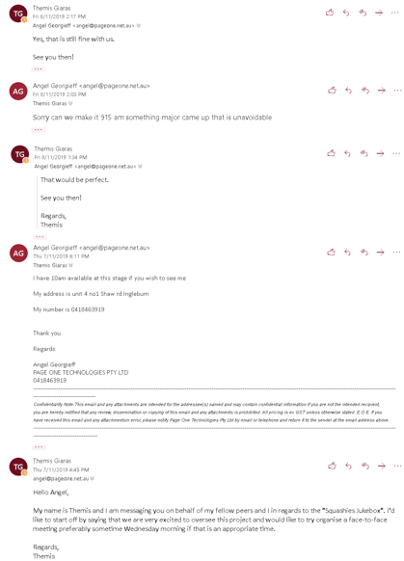

### Scheduling Regular Meetings with Client

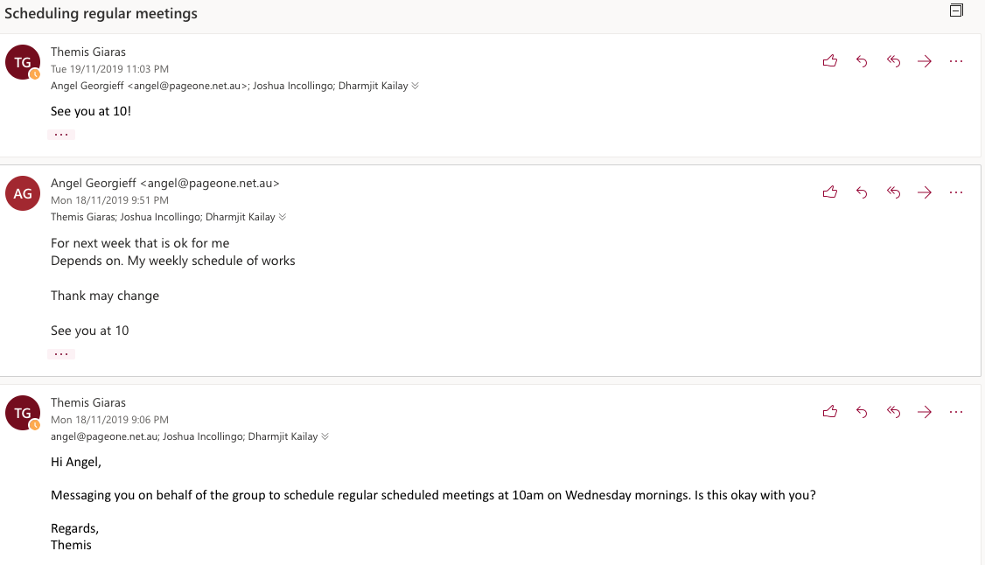

### Organising Regular Weekly Meetings With Academic Supervisor

### Sending Agendas for Second Academic Supervisor Meeting

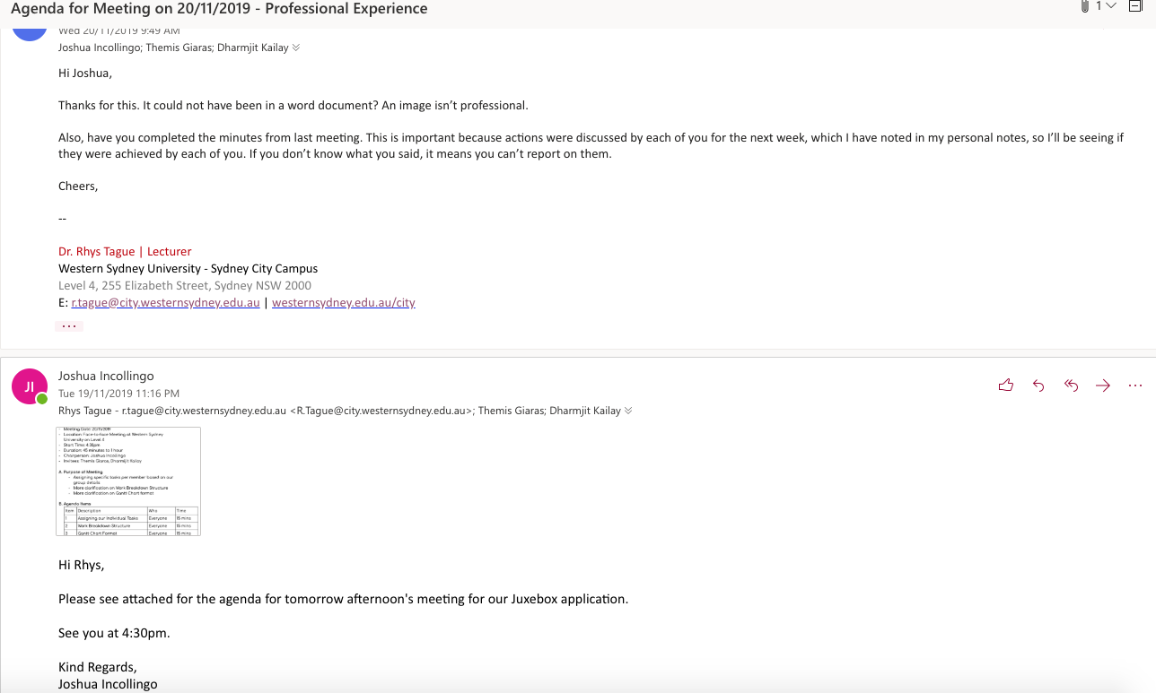

# Gantt Chart

Please refer to the separate PDF file “Gantt Chart FULL”.

# Conclusion

Through this project plan, we have defined the client’s requirements for the Jukebox application, broken down the entire project and mapped it out based on time, as well as worked around each group member’s strengths and weaknesses and will continue to assign individual tasks as such. With every strong team comes strong communication, and if we, as a group, can continue working together with a positive mindset and continually keeping up to date with all our tasks and making sure we all keep on task, there is no reason why we can’t make a high-quality Jukebox application for Squashlands Gym and Fitness Centre